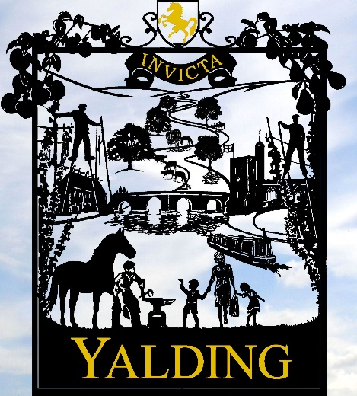

CCTV Access Request Form

BEFORE completing this form, please read the following.
Requests from police, statutory bodies, legal representatives or media organisations will be verified through official channels and do not require personal identity documents. They will be verified through organisational credentials, case references or crime references rather than personal ID.
Identity documents are required for requests made by individuals seeking access to images of themselves. To help establish your identity your application must be accompanied by one official document that clearly proves your identity.
For example:
- Driving licence
- Passport
- Other official document that shows your name and address. You may provide photocopies of these documents but might be required to produce the original documents at a later stage.
The release of images to members of the public or external organisations will be carried out in accordance with the UK General Data Protection Regulation (UK GDPR), the Data Protection Act 2018 (DPA), the Council’s CCTV Policy, and the Information Commissioner’s Office (ICO) Video Surveillance Guidance.
Requests from law enforcement agencies are handled separately under Part 3 of the DPA 2018 (Law Enforcement Processing).

The Parish Council reserves the right to edit images to meet its obligations under UK GDPR, the DPA 2018, and the ICO’s Video Surveillance Guidance. For example, blurring or otherwise disguising the identities of third parties.
Any images released to a member of the public or outside body may not be used for any commercial or media purpose (this includes social media) or shared with any person(s) or organisations, without specific permission from Yalding Parish Council.
As identified in the parish council’s CCTV policy; images will only be held for a period of 31 days and then deleted. Any requests outside of this time period will be rejected.
The parish council reserves the right to decline this request if it doesn’t meet the criteria stated above, the parish council’s CCTV policy, or is manifestly unreasonable. The Council may refuse requests that are vague, unsupported, or lack sufficient detail to locate the footage.
The parish council has one calendar month to respond to this request.
The requestor must sign for receipt of the image(s)
Date of recording:  Click or tap to enter a date. | Place of recording:  Click or tap here to enter text. | Time of recording:  Click or tap here to enter text.
Applicants Name: Click or tap here to enter text.
Telephone number: Click or tap here to enter text.
Applicants Address (including post code):
Click or tap here to enter text.
Description of Applicant and any distinguishing features (e.g. clothing)
Click or tap here to enter text.
Reason for request - to be submitted to the Parish Council.
Click or tap here to enter text.
Declaration: I confirm that I agree with the conditions of access to CCTV images held by Yalding Parish Council and have provided accurate information in relation to this request.

Signed: Click or tap here to enter text.

Date: Click or tap to enter a date.

For office use only
Request number:
Date response required by:
Images found (Y/N):
Authorisation images can be released:
Image format of release:
Method of release:
Reason(s) if images can’t be released:
Date completed:
Completed by:

